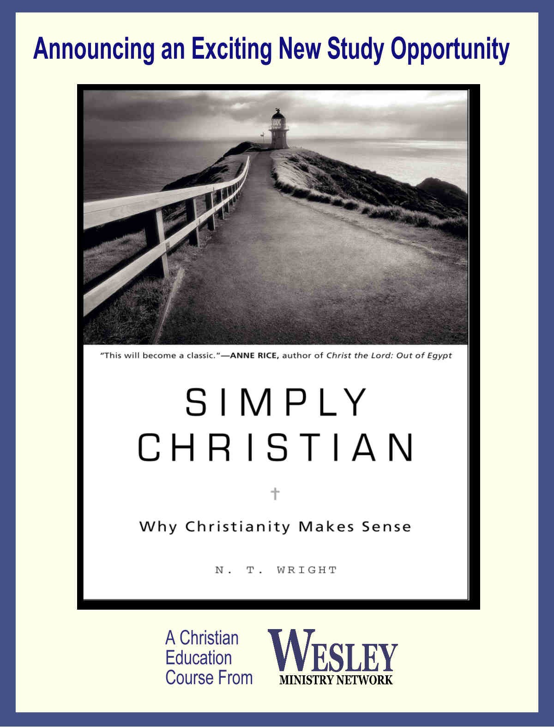

Time:
Dates:
Location:

Time:
Dates:
Location:

You are invited to be part of this inspiring study in which we examine how the ancient truths of Christianity may be lived out today.
You are invited to be part of this inspiring study in which we examine how the ancient truths of Christianity may be lived out today.

S I M P L Y C H R I S T I A N
Why Christianity Makes Sense
S I M P L Y C H R I S T I A N
Why Christianity Makes Sense

Time:
Dates:
Location:

Time:
Dates:
Location:

You are invited to be part of this inspiring study in which we examine how the ancient truths of Christianity may be lived out today.

S I M P L Y C H R I S T I A N
Why Christianity Makes Sense
You are invited to be part of this inspiring study in which we examine how the ancient truths of Christianity may be lived out today.

S I M P L Y C H R I S T I A N
Why Christianity Makes Sense

From:

A Wesley Ministry Network course.
www.WesleyMinistryNetwork.com

A Wesley Ministry Network course.
www.WesleyMinistryNetwork.com

A Wesley Ministry Network course.
www.WesleyMinistryNetwork.com

A Wesley Ministry Network course.
www.WesleyMinistryNetwork.com

From:

From:

From:

