
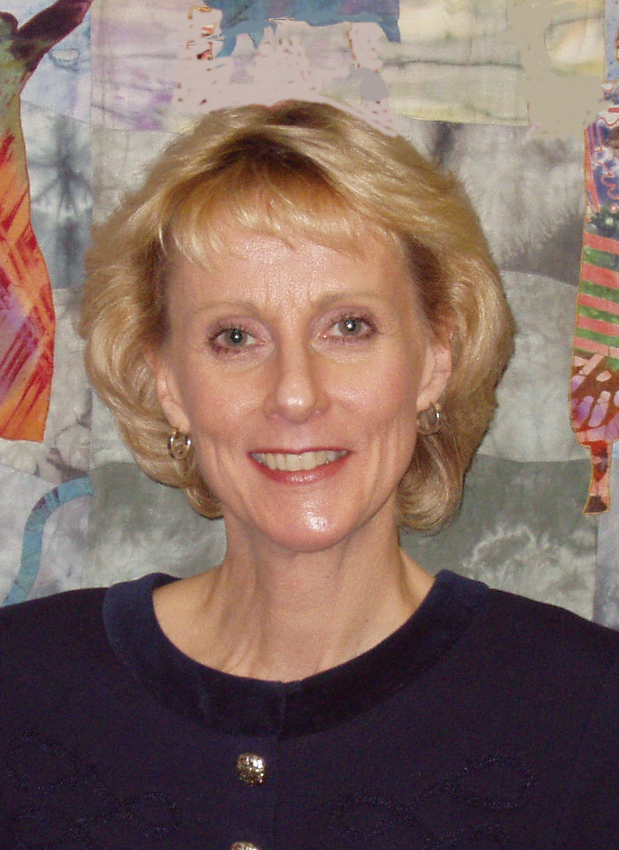
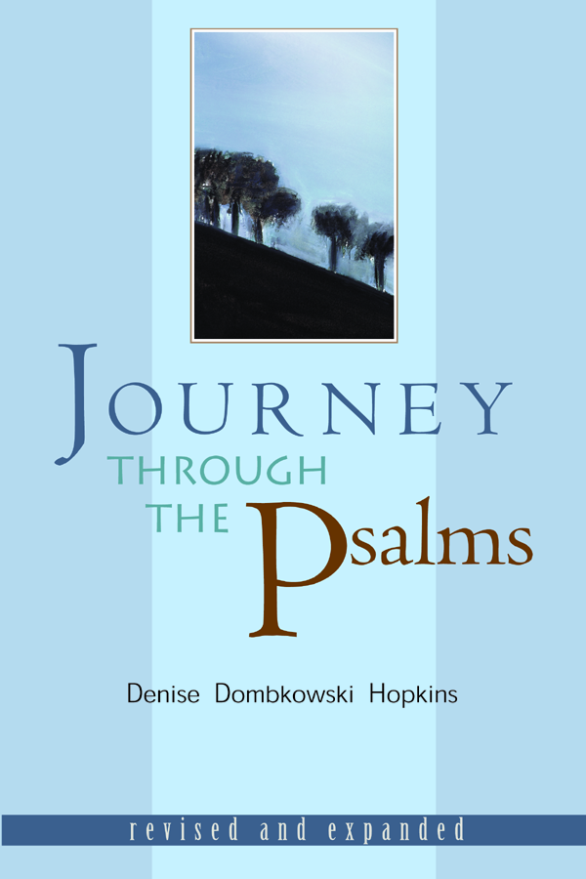
Bring the Psalms to life for prayer and worship in your church and learn to approach God with the emotional intensity of the ancient psalmists. This course is based on the celebrated book Journey through the Psalms and includes lecture, choral speaking, visual art and other media.

Time:
Dates:
Location:
Interested? Please Contact:

Denise Dombkowski Hopkins is Professor of Hebrew Bible at Wesley Theological Seminary. She holds a doctorate in Biblical Studies from Vanderbilt University and has studied at the Ecumenical Institute (Tantur) on the West Bank.

Announcing an Exciting New Study Opportunity:

Journey

The

Psalms

Through

With Eight Video Lessons
By Dr. Denise Dombkowski Hopkins

