
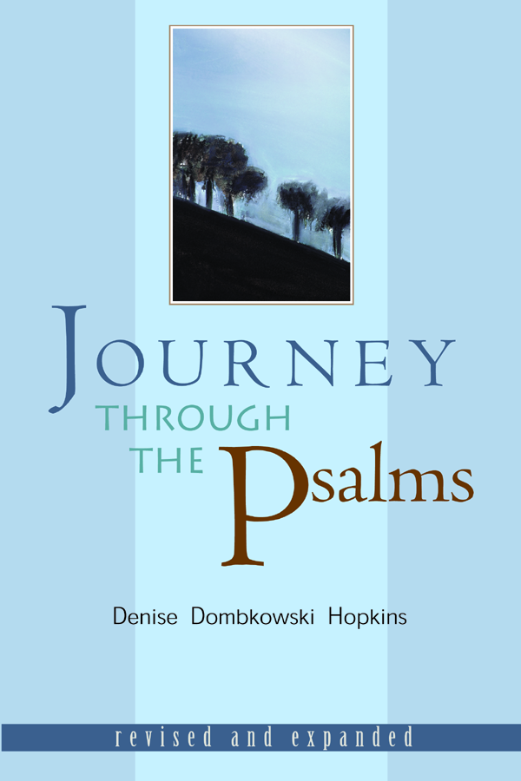
Time:
Dates:
Location:

Interested? Please Contact:

Announcing an Exciting New Study Opportunity From Wesley Ministry Network:

Journey

Through

The

Psalms

Bring the Psalms to life for prayer and worship in your church and learn to approach God with the emotional intensity of the ancient psalmists. This course is based on the widely-used book Journey through the Psalms and features eight video lessons by its author, Dr. Denise Dombkowski Hopkins, Professor of Hebrew Bible at Wesley Theological Seminary.

Announcing an Exciting New Study Opportunity From Wesley Ministry Network:

Journey

Through

The

Psalms

Bring the Psalms to life for prayer and worship in your church and learn to approach God with the emotional intensity of the ancient psalmists. This course is based on the widely-used book Journey through the Psalms and features eight video lessons by its author, Dr. Denise Dombkowski Hopkins, Professor of Hebrew Bible at Wesley Theological Seminary.

Time:
Dates:
Location:

Interested? Please Contact:

