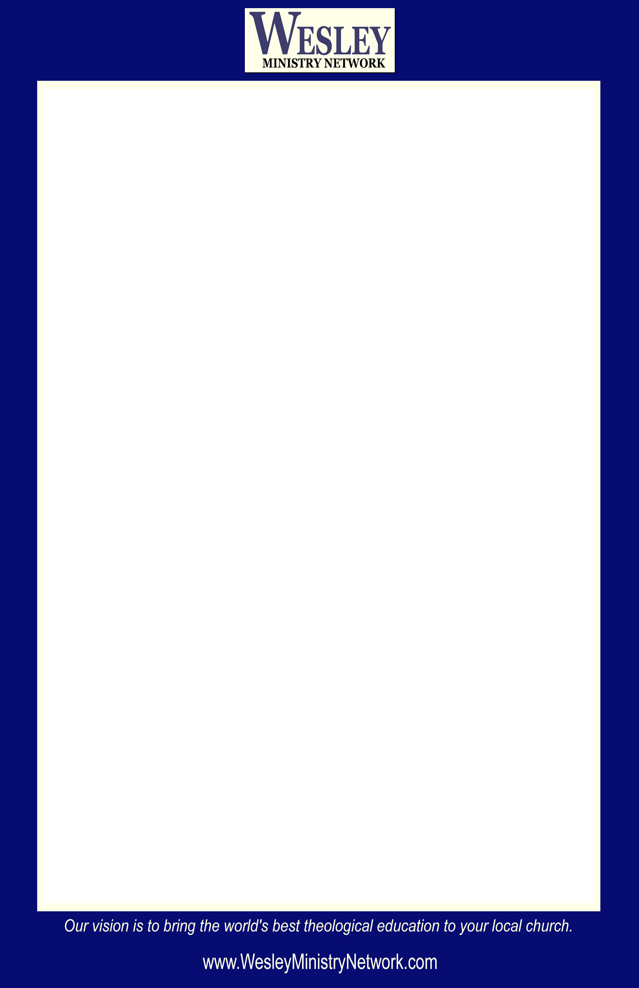

Announcing an Exciting New Study Opportunity:

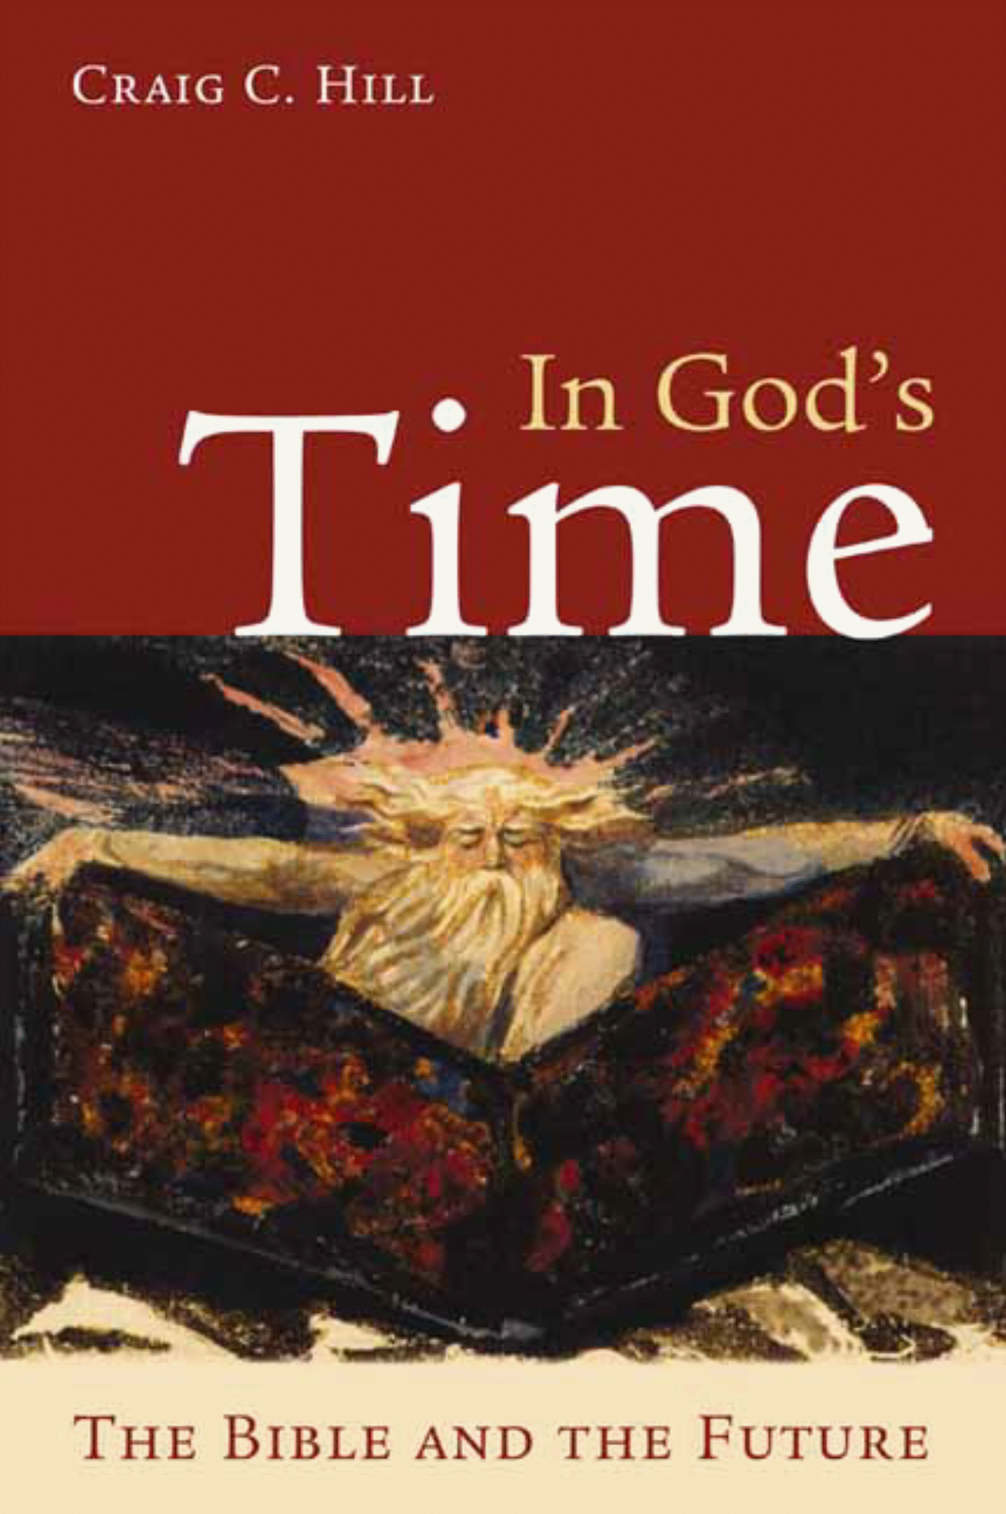
Time
The Bible and the Future

With Ten Video Lessons
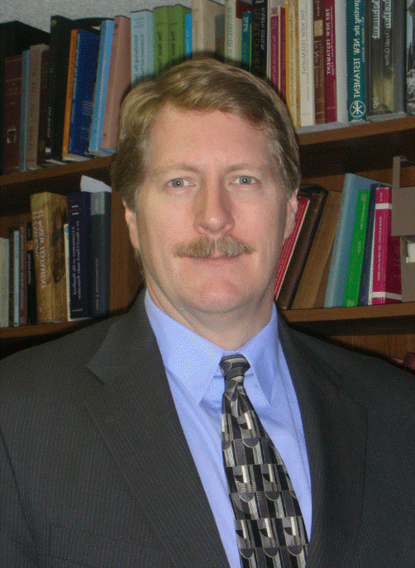
By Dr. Craig C. Hill
Enormous confusion exists today concerning the Bible’s teaching about the future. The In God’s Time course offers an alternative to sensationalist perspectives, an alternative that is at once faithful and sane, readable and scholarly. Dr. Hill encourages Christians both to take seriously and to think sensibly about God’s ultimate victory.

Time:
Dates:
Location:

Craig C. Hill is Professor of New Testament at Wesley Theological Seminary in Washington, D.C., and Director of the Wesley Ministry Network. Hill holds a doctorate in New Testament History from Oxford University and served as a Henry R. Luce Fellow at Yale University and as a Visiting Fellow at Cambridge University.

Interested? Please Contact:

