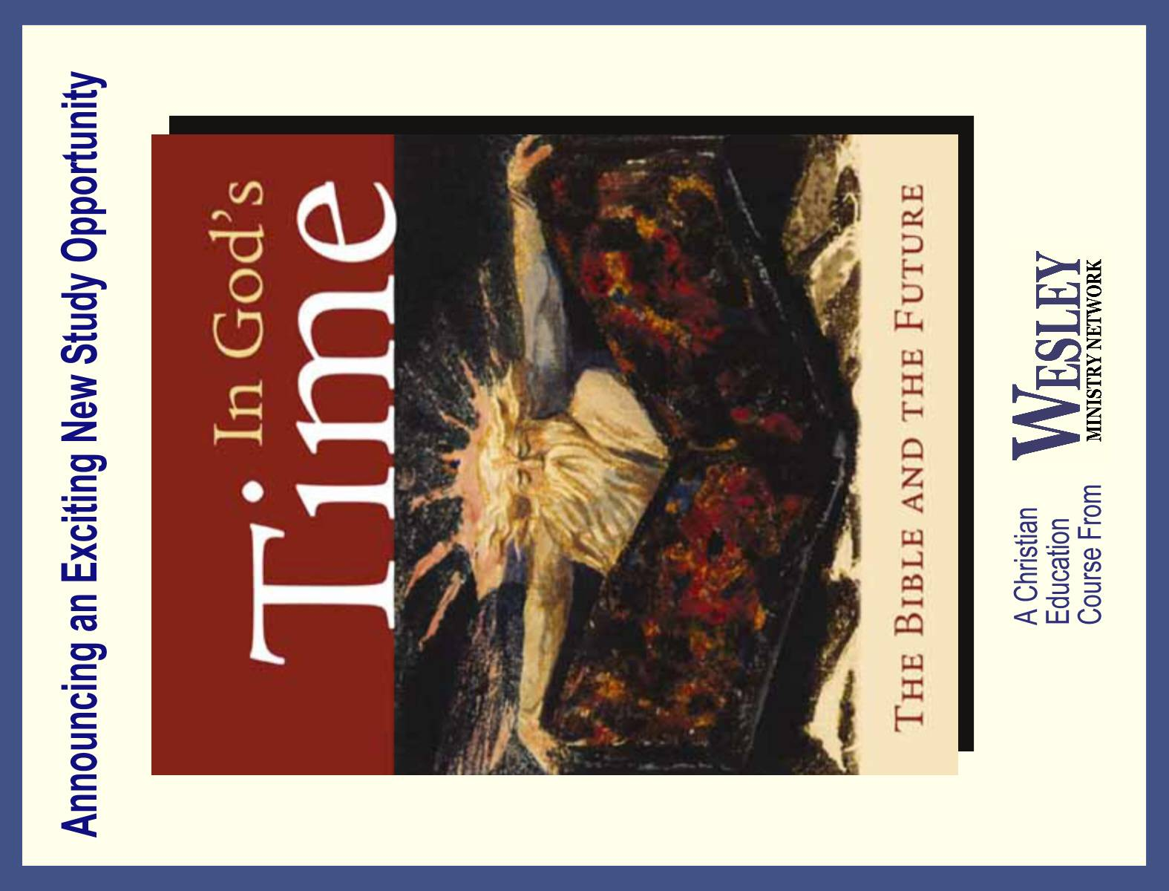

From:



Enormous confusion exists today concerning the Bible’s teaching about the future. You are invited to join us as we study this often perplexing but always fascinating subject. The course is based on Craig C. Hill’s acclaimed book and includes ten video lessons by the author.
Time:
Dates:
Location:
A Wesley Ministry Network course.
www.WesleyMinistryNetwork.com

A Wesley Ministry Network course.
www.WesleyMinistryNetwork.com
Enormous confusion exists today concerning the Bible’s teaching about the future. You are invited to join us as we study this often perplexing but always fascinating subject. The course is based on Craig C. Hill’s acclaimed book and includes ten video lessons by the author.
Time:
Dates:
Location:
A Wesley Ministry Network course.
www.WesleyMinistryNetwork.com

A Wesley Ministry Network course.
www.WesleyMinistryNetwork.com

From:

Enormous confusion exists today concerning the Bible’s teaching about the future. You are invited to join us as we study this often perplexing but always fascinating subject. The course is based on Craig C. Hill’s acclaimed book and includes ten video lessons by the author.
Time:
Dates:
Location:
A Wesley Ministry Network course.
www.WesleyMinistryNetwork.com

A Wesley Ministry Network course.
www.WesleyMinistryNetwork.com

Enormous confusion exists today concerning the Bible’s teaching about the future. You are invited to join us as we study this often perplexing but always fascinating subject. The course is based on Craig C. Hill’s acclaimed book and includes ten video lessons by the author.
Time:
Dates:
Location:
A Wesley Ministry Network course.
www.WesleyMinistryNetwork.com

A Wesley Ministry Network course.
www.WesleyMinistryNetwork.com

From:

From:

